**Introduction to Deep Learning**

Deep learning uses complex neural networks, inspired by the brain, to learn from data and improve at tasks like image recognition and speech. It's powerful but requires a lot of data and computing.

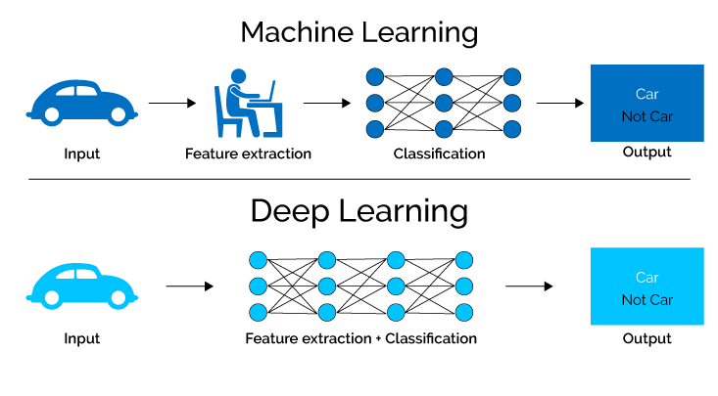

**What is Neuron**

**Brain Neuron:**

A biological cell that transmits information through electrical and chemical signals. It connects to other neurons in a vast network, allowing for complex thought, memory, and learning.

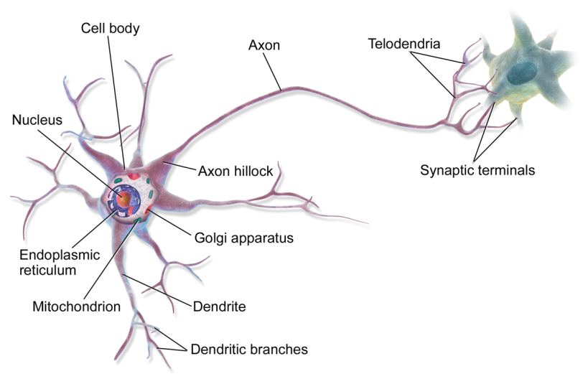

**Deep Learning Neuron:**

A mathematical function loosely inspired by a brain neuron. It processes information within an artificial neural network, but lacks the biological complexity and connections of a real neuron.

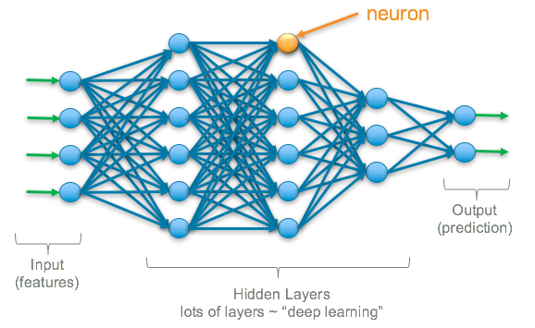

**What is Deep Learning**

* Deep Learning (DL) is a type of machine learning.
* It uses artificial neural networks inspired by the human brain.
* DL learns patterns from huge amounts of data.
* It's used for tasks like image recognition and language translation.
* DL has revolutionized many fields with its accuracy and capabilities.

**Neural Network**

**Brain:**

**Biological:** Made of real neurons, complex cells that transmit electrical signals and connect with thousands of others.

**Learning:** Through experience and interaction, connections between neurons strengthen or weaken, shaping memories and skills.

**Highly adaptable:** Can learn entirely new things and perform many different functions.

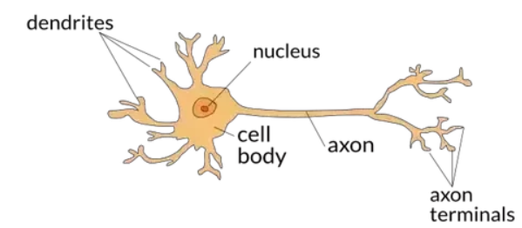

**Deep Learning:**

**Artificial**: Inspired by brain structure, uses mathematical functions as "neurons" in layered networks.

**Learning**: Trains on massive datasets, adjusting connections between layers to improve at a specific task.

**Limited adaptability**: Excels at its trained task but struggles with entirely new situations.

